Data Center and Structured Cabling Project
TECHNICAL SPECIFICATIONS
Particulars | QTY
- Data Center
- Supply & Installation of tempered fixed glass in anodized aluminum frame, 43"x102" x ½” | 3
- Supply & Installation of tempered fixed glass in anodized aluminum frame, 32"x102" x ½” | 4
- Supply & Installation of sliding door, 32"x102" x ½” | 1
- Supply & installation of hardiflex partition in metal furring, 130" x 102” x 1/2" | 1
- Structured Cabling for the Administration Building
- Active and Passive Components
- Precision Airconditioning Unit (PACU)  - 300mm, Air Cooled, Self-contained 200-240v 50Hz  - InRow SC Air Cooled Self Contain  - Air distributor  - 1200 CFM  - Horizontal  - Rear Return  - 4.90kW  - Multi function LCD status and control console  - BSMI,C-tick,CE,EN 55022 Class A,FCC Part 15 Class A,ICES-003,UL Listed,VDE,VCCI  - 2390Watts  - 14Amps  - 50 Hz +/- 3 HzHz  - includes installation and commissioning, labor and materials | 1
- Server  - Rack mount  - With VGA and DVD ROM, USB Ports  - Processor: 1 CPU, Intel® Xeon® E5-2630 v3 2.4GHz,20M Cache, 8.00GT/s QPI, Turbo, HT,8C/16T (85W) Max Mem 1866Mhz  - Memory : 2 x 16GB RDIMM, 2133mt/S, Dual Rank  - Hard Drive: 2 x 600GB 15K RPM SAS 6Gbps 2.5 Hot-plug Hard Drive  - PSU : Dual, Hot-plug Power Supply  - Hardware RAID support  - Warranty : 3yrs Pro Support, Next Business Day Onsite Service | 1
- Server Racks  - Dimension – 42 U Height : 2000 mm Width: 600 mm Depth: 1200 mm  - Single perforated locking door  - Split rear door, locking  - Split side panels, locking  - High density cable entry roof (2500+ cat5 cables)  - Low profile cater and levelling feet  - 2 Sets 19” EIA rails.  - 2 Full height rack PDU/cable management brackets  - Hardware kit (Qty 50M6 Cage Nuts and screws)  - Bolt down brackets  - Central grounding point  - Standard Compliance: (19”) rack mount equipment, EIA310E  - Environmental Compliance: RoHS  - Additional 1,500pcs M6 Cage Nuts  - 4 units additional PDU | 2
- UPS battery  - 12V, 9Ah | 10
- Air-conditioning Unit  - 1 hp, Split Inverter Type | 1
- EIA 19-inch Rack  - Wall mounted  - Enclosure Cabinet  - Heavy-duty steel  - Perforated | 5
  - KVM set
    - Include 1U 19" widescreen LED/LCD console drawer (VGA and DVI compatible with the servers) with Keyboard and Mouse
    - LCD/LED Monitor support Full HD with 1080p resolution
    - Include slide rails with fixed positions to prevent drawer movement when typing
    - Include the KVM switchbox with server modules and cables that support at least 16 servers
    - includes adapters and other necessary peripherals
- After sales support

TERMS OF REFERENCE
- DATA CENTER
  - Current IT Office Floor Plan
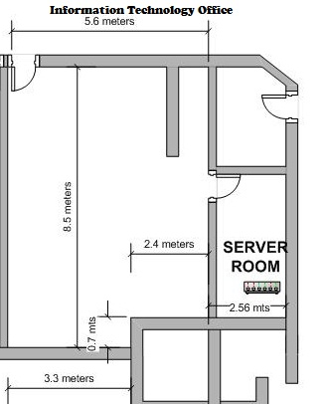

  - Proposed IT Office Floor Plan
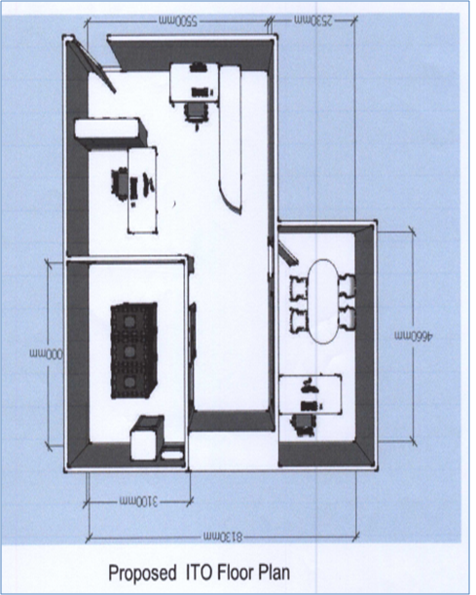

  - Scope of works
    - Project planning
    - Installation
      - Labor and materials
      - Civil and electrical works (provision/installation)
      - Setup and configuration
      - Cable Tagging, Testing and commissioning
      - Other necessary components
    - Equipment power-up and pre-configuration
    - Integration, configuration and testing
    - Fine tuning and monitoring
    - User and technical training
    - Documentation
      - User manuals
      - Network diagram
      - Line diagram
      - Expansion plan (scalable design)
    - Warranty
      - Three (3) years warranty on hardware and software with next business day replacement for active devices
    - Technical support
      - Two (2) years on-site free labor and technical support
      - Two (2) years 24x7 help desk facility and virtual technical support

The contractor shall furnish all labor, materials, tools and equipment, and perform all operations necessary to complete the supply, delivery, installation, testing and commissioning of Structured Cabling for a minimum of one hundred forty five (145) data nodes, network switches, and transfer and improvement of the IT Office Data Center. The contractor must provide advance training for IT Personnel and other interested personnel for the Network Equipment/switches, basic trouble shooting for the Structured Cabling and Management of Data Center for at least five (5) days.

  - Construction of the Data Center
    - Provision of Floor Plans and Working Drawings
The proponent shall submit a blue print of General Perspective that includes other working drawings such as Floor Plan, electrical computation design for review and evaluation if the existing electrical system will suffice.
Safety Enclosures:
The contractor shall provide safety barriers, enclosures, warning signs and other safety nets at the working area to warn passersby of the ongoing work to avoid untoward incidents in the course of the construction works.
    - Supply, delivery, installation of materials and labor for the following civil works:
      - Construction of new data center room using glass panel enclosure (tempered clear glass)
      - Door:
        - Clear Tempered Glass Door with Stainless Handle & complete accessories
        - Door frame size should be sufficient to allow for easy introduction and removal of equipment. For new construction, doors should be 42 inches wide and 9 feet tall. If hinges are exterior to the room, doors should use locking hinge pins.
        - Should be installed with Biometrics System Magnetic door lock mechanism set
        - An electronic access control system should be in place and log all access to data center room
        - Secured doors must fail open in a fire emergency.
      - Windows:
        - Installation of Hardiflex board and painting (blend w/ existing color)
        - Provision for the PACU ducting
      - Waterproofing - Application of waterproofing materials on new surface to avoid leakages
      - Board Partition - Moldings and Base Boards
      - The ceiling of the room should be at least 9 feet high.
      - Floors: an anti-static floor surface is recommended
    - Supply, delivery, installation of materials and labor for the following electrical, electronic and mechanical works
      - Ceiling: Installation of ceiling data and power cables and pipes
      - Biometrics System Magnetic door lock mechanism set
      - Back up air conditioning unit – 1hp split inverter type
      - Power provisioning for the PACU, 2 x 6 KVA UPS
      - Power provisioning for the active components
      - Power outlets and lightings, electrical panels
      - Transfer of existing electrical panel board
    - Supply, delivery, installation, set-up and commissioning of the following equipment and materials:
      - Cable tray
      - Cable Ladder
      - Precision Air Conditioning Unit (PACU)
      - 1 server type rack and 1 network type rack that are PACU compatible
      - Required Cables and other materials/accessories
      - Replace existing battery of 6KVA UPS
      - Supply, delivery and installation of rack mountable 6 KVA UPS
    - Transfer from existing room to the new Data Center room
      - Data cabinet, racks, components and / or equipment (servers, switches, etc.)
      - Re-routing, arranging and tagging of (structured) cables and wires to the new server room
      - Supply and Installation of materials and or equipment needed
- STRUCTURED CABLING FOR THE ADMINISTRATION BUILDING

  - Cabling Layout Plan Admin Building 1st Floor.
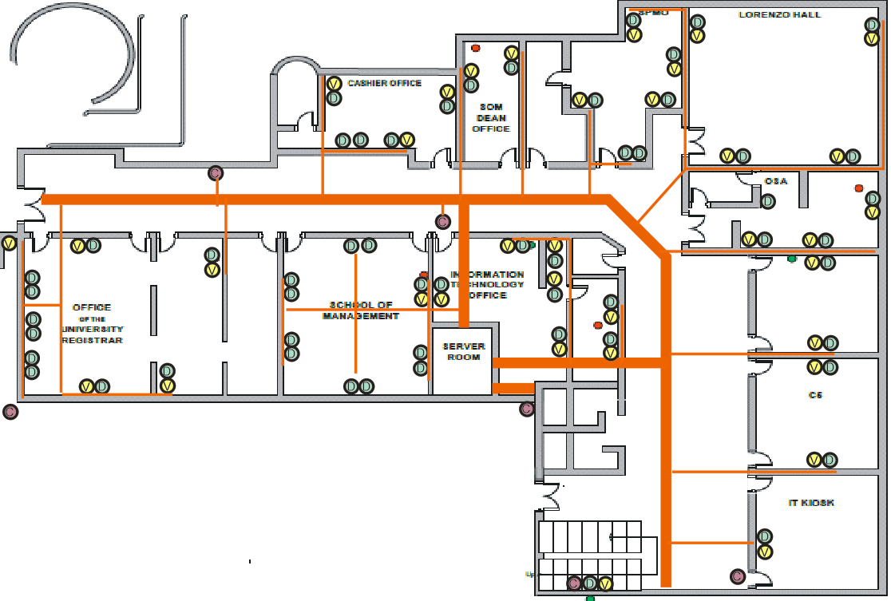
  - Cabling Layout Admin Building 2nd Floor.
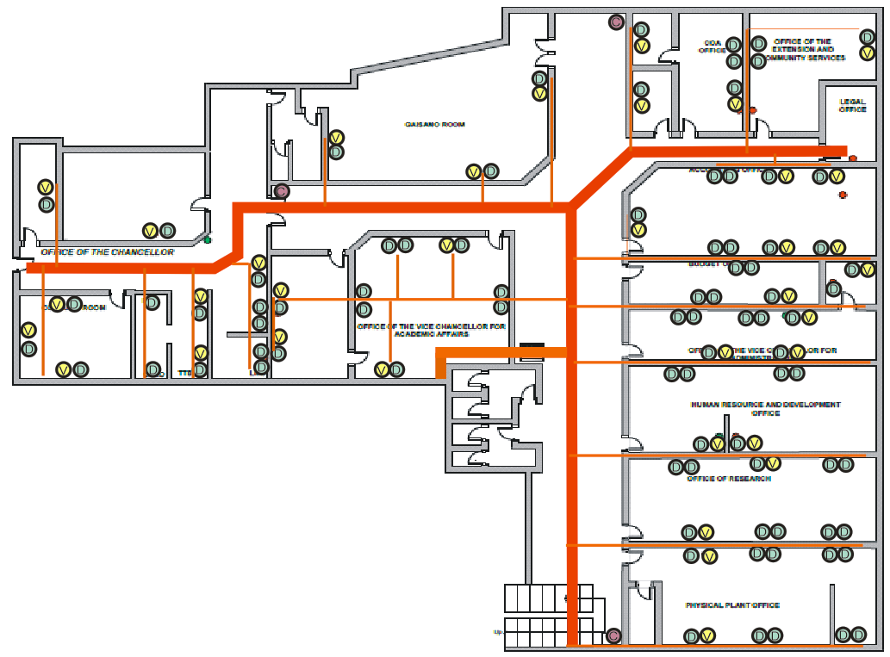

  - Installation

    - A total of 218 nodes of the two floors.
    - The common path of the cabling must be placed in an enclosed cable tray with removable cover on top and securely attached in the concrete ceiling/trusses completely hanging without touching the ceiling joints.
    - Cable Tray specifications:
      - Must be metal with rust proofing paint or better.
      - Minimum width of 6inches and at least 2inches height.
      - Using big PVC pipes that serve as cable tray is strictly prohibited.
    - Cabling from the second floor must be dropped directly to the server room located in the ground floor.
    - Cables coming out from the cable tray leading to the outlet must be enclosed by at least PVC pipe.
    - A Connector/Adapter must be used to securely attached the PVC pipe to the cable tray.
    - Cables drop from ceiling to the outlet must be at least covered with good quality decorative moulding for aesthetics.
    - All outlets except for IP Camera must be terminated in an I/O with wall plate of the same brand of the cable.
    - All cables must be terminated in the patch panel of the same brand of the cable.
    - MULTIPLE BRANDS IS NOT ALLOWED. All Cables & passive components must be of the same brand. The brand must be known for durability and reliability (should be supported with industry certification).
    - Cable to use is UTP CAT6.
    - The whole structured cabling must provide at least a GIGABIT bandwidth.
    - Each node must be tested using high-end equipment to determine if the node supports GIGABIT bandwidth.
    - Patch panels must be labeled properly identical to each end node outlet.
    - The structured cabling must last for at leat 10 years.
    - A certification from a certified structured cable installer is a MUST.
    - Horizontal and backbone cables should have an end-to-end labelling.
    - A unique identifier shall be marked on each faceplate to identify it as connecting hardware. Each port in the faceplate shall be labelled with its identifier.
    - A unique identifier shall be marked on each piece of connecting hardware to identify it as connecting hardware. Each port on the connecting hardware shall be labelled with its identifier.

  - Documentation

    - An as-built drawing shall be supplied by the contractor showing all the locations and identifiers for Horizontal cable routing and terminations and Telecommunications outlets/ connectors
    - The format shall be computer-based, and both soft copies and hard copies shall be part of the as-built package.
    - All records shall be created by the service provider and turned over at the completion of work. The format shall be computer-based, and both soft copies and hard copies shall be part of the as-built package. The minimum requirements include:
      - Cable records must contain the identifier, cable type, and termination position at both ends, splice information as well as any damaged pairs/ conductors.
      - Connecting hardware and connecting hardware position records must contain the identifier, type, damaged position numbers, and references to the cable identifier attached to it.
      - Test documentation on all call cable types shall be included as part of the as-built package.
    - All reports shall be generated from the computer-based program used to create the records cited above. These reports should include but not limited to: Cable Reports, Cross-connect reports and Connecting Hardware Reports

  - Passive Components
    - Patch panel 1U – at least 10 pcs of 24ports each
    - Cable manager 1U – at least 10pcs
    - Patch Cords (factory terminated) 1meter – at least 218 pcs
    - Patch Cords (factory terminated) 3meters. – at least 218 pcs
- ACTIVE AND PASSIVE COMPONENTS

  - Precision Air-conditioning Unit (PACU)

- PACU is based on Self-Contained In-row Cooling Architecture that captures hot exhaust air directly from the IT equipment, thereby increasing the unit's sensible cooling capacity over traditional cooling architectures.
- Horizontal airflow pattern which removes heat close to the source of generation in the hot aisle and distributes cold air to the front of the racks in the cold aisle
- It is Air-cooled, width is 300mm and preferably WHITE if color is available
- Should have properly installed Exhaust Duct Kit
- Have Automatic restart functionality that returns the unit to its last operating status in the event of a power failure.
- Fault-tolerant fan system in the event of a fan failure, the remaining fan(s) will continue to operate.
- Fans and electronics module can be readily replaced without uninstalling the unit.
- Should optimize efficiency through Variable-Speed Fan. Variable speed fans that reduce energy consumption during off-peak cooling periods.
- Have Multi-function LCD status and control console
- Should have a built-in Intelligent Controls Precise monitoring local and remote, intelligent control, friendly communication
- Should have Rack inlet temperature control that reduces the risk of hot spots at the rack level
- Active response controls that monitors and actively adjusts cooling capacity to ensure proper server inlet temperatures. Through the microprocessor controller, visibility into the operation and health of the unit is provided.
- Network interface that provides management by connecting the device directly to the network with a dedicated IP address, avoiding the need for a proxy such as a server. Management is available via Web browser, Telnet or SSH. Notification features inform you of problems as they occur.
- Has remote management of key alarm conditions such as fan failure and leak detection via SNMP, telnet, and web browser is possible with optional Remote Monitoring Unit, specifically designed for the High-Density Cooling Enclosure.
- The power to PACU must support single phase plus ground
- Should have Humidity and temperature sensors
- The unit can be combined with a Rack or Hot Aisle Containment System to eliminate hot air mixing and maximize cooling efficiency
- Should have Washable filters to easily maintain and clean. The deep loading mesh filter removes particles from the return air stream.

  - Server

  - Server Racks
Should be the same brand with the PACU
    - Proposed List of Devices for Rack 1
Devices | No. | Size (U) | Total
PLDT 24 ports ODF | 1 | 1 | 1
Cisco 3900 | 1 | 3 | 3
Cisco 2900 | 1 | 1 | 1
Huawei Optix OSN 500 (PLDT) | 1 | 1 | 1
Comclark Telco Systems | 1 | 1 | 1
Huawei Optix RTN 605 (PREGINET) | 1 | 1 | 1
Palo Alto PA 500 | 1 | 1 | 1
Juniper SSG 140 | 1 | 1 | 1
Dell PowerEdge R410 | 2 | 1 | 2
Dell PowerEdge R210 | 2 | 1 | 2
Dell PowerEdge R300 | 1 | 1 | 1
Apple Xserve PowerPC G5 | 4 | 1 | 4
Future Aruba wireless controller 7205 | 1 | 1 | 1
Future CCTV VMS SERVER | 1 | 2 | 2
Future VOIP PBX | 1 | 1 | 1
Future Fileserver (Record Management) | 1 | 2 | 2
Future ITO server (CONVERSION DESKTOP SERVERS) | 2 | 1 | 2
Future New UPS | 1 | 4 | 4
Total = |  |  |  | 31

    - Proposed List of Devices for Rack 2
Devices | No. | Size (U) | Total
Optical Distribution Frame | 3 | 1 | 3
HP A5500 Series Switch JD374A | 2 | 1 | 2
HP 2620-24 J9623A | 6 | 1 | 6
3Com Baseline Switch 2226 SFP Plus | 3 | 1 | 3
3Com Baseline Switch 2920 SFP Plus 3CRBSG2093 | 2 | 1 | 2
Liebert GXT 6kVA(battery to be replaced) | 1 | 4 | 4
Future Switches Patch Panel | 12 | 1 | 12
Future Optical Distribution Frame 48 CORE | 1 | 2 | 2
Future HP A5500 Series Switch JD374A from Aruba Project | 1 | 1 | 1
Total Size = |  |  |  | 35
  - UPS battery, 12V, 9Ah
  - Air-conditioning Unit, 1 hp, Split Inverter Type
  - EIA 19-inch Rack
  - KVM set
- After Sales Support
I. Warranty
- One year product warranty on its entire hardware products, including free parts and labor. The product warranty covers the components against defects in material or workmanship under normal and proper use, includes parts and labor coverage on cable and connecting hardware. Warranty shall also cover the immediate replacement of equipment (service unit) or defective parts free of charge.
II. Support Services
- Technical support must be available 24 X 7.
- Technical support response time must be 1 hour for phone support.
- Technical support must also be available via the Internet and/or email.
- The vendor must provide procedures on support and problem escalation.
- When the hardware cannot be repaired on site within 24 hours due to extraordinary hardware difficulties, the bidder must provide service unit during the maintenance period.
III. Project Implementation Support
- The winning bidder must deliver a Project Management Plan detailing the activities and estimated man-hours to implement the project. UP MINDANAO shall review and approve the plan. The Project Management Plan must include a Test and Acceptance Checklist that will be reviewed and approved by UP MINDANAO.
- The winning bidder's Project Manager must be qualified with at least three (3) years experience in similar projects. Resume and certificate of employment should be submitted.
- The bidder must coordinate with the IT personnel whenever new installations will be done.
- The winning bidder shall define together with personnel of UP MINDANAO the configuration parameter requirements of the project.
- During cut-over, the winning bidder and personnel of UP MINDANAO shall ensure that all applications are simulated and successfully tested. Winning bidder shall submit a report to ITO for validation and acceptance.
- The winning bidder shall prepare and submit as-built documentation of implemented network set-up and configuration.
- The winning bidder shall prepare final acceptance document that will be reviewed and approved within two (2) weeks after installation.
- The winning bidder shall deploy switch(es) as service unit/s for the duration of warranty period after final acceptance in case there is a need to replace a defective unit.
- The Bidder shall provide training for the IT personnel about the installation and configuration.

IV. Pre-installation
- Submission of list of personnel who will be assigned to implement the project and with photocopy of ID – 3 sets;
- Secure necessary permits for the work to be done, if any;
- Documentation of existing connections
- The technical and licensed personnel assigned to the project by the winning bidder should meet, present and discuss with UP Mindanao their work plans and proposed solution
V. Installation
- Supply, delivery and install the required components as specified in the Workplan;
- Regularly coordinate with UP Mindanao’s IT personnel for every phase of the project;
- Complete the transfer of components from the old room to the new room within 24 hrs;
- Complete the delivery, installation, configuration and commissioning of the entire project within forty five (45) calendar days from the receipt of the Notice to Proceed.
IV. Post-Installation
- Conduct free training for the IT personnel and other interested personnel of UP MINDANAO on the basic maintenance and operational requirements of structured cabling and the equipment and software supplied for a minimum of five (5) working days.
- Provide at least one (1) copy of the technical manual/documentation (English) in printed hard copy and electronic (soft copy) formats. The documents include Cabling and equipment installation, operation, configuration and testing.
- Provide at least 1 year warranty for all active equipment and components supplied.
- Render support services to UP MINDANAO within the warranty period as follow:
  - Technical support will be provided through phone calls or email within regular working hours from Monday to Friday, 8:00AM to 5:00PM
  - On-site services shall be rendered within four (4) working hours after the problem has been reported. For problems reported after 4PM, services shall be rendered at 9:00AM of the following working day.
  - If the supplied equipment is found defective and need to be pulled-out, the contractor shall provide replacement with the same or higher specifications within 24 hours.
- Rectify and or/replace any part that fail to pass any test/inspection or make alteration necessary to meet the specification.
- Responsible and accountable for any damage caused solely by the Contractor or its agent to the UP MINDANAO as a direct result of the installation maintenance, and removal of any cabling components and devices.
- Cleaning and clearing of sites. All debris or waste materials shall be immediately removed by the contractor from the UP MINDANAO premises with proper coordination with concerned unit of UP MINDANAO.
VI. DUTIES AND RESPONSIBILITIES OF UP MINDANAO
- Assist prospective bidders during the conduct of site survey – ITO Staff
- Grant the Contractor authorized representative access to its premises and facilities located therein to perform its obligations, provided that such representative shall be accompanied by the duly assigned ITO personnel.
- Reject any unit or any part thereof that fail to pass any test and/or inspection or do not conform to specifications.
- Pay the Contractor in accordance with condition set in the Payment Scheme.
- Issue a Certification of Inspection and Acceptance upon determination by the UP MINDANAO IT OFFICE that the delivered and installed equipment and components are usable and in god working condition

